

Lesson Plan

Balloon Buggies

www.tts-shopping.com

Product Code: TE10020

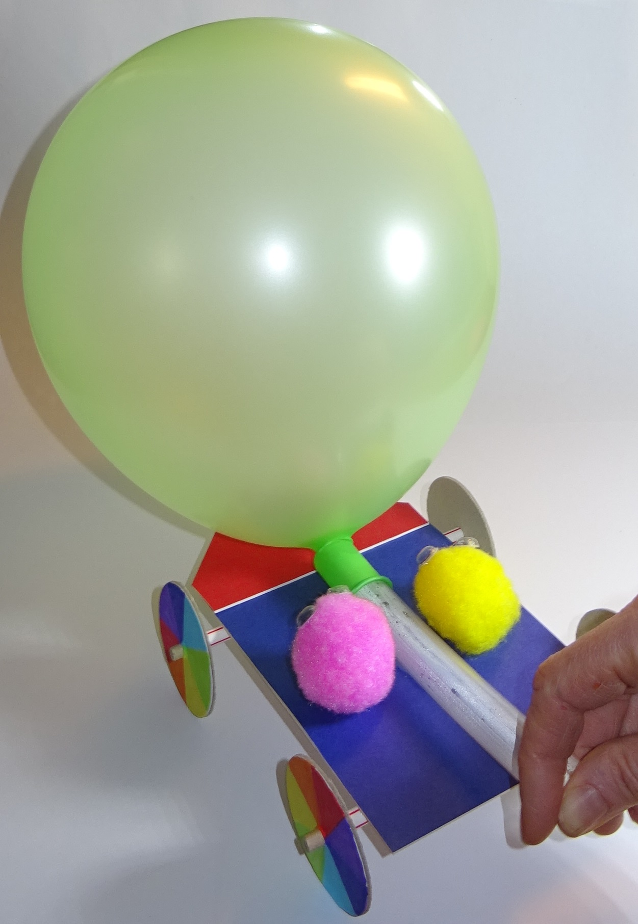

**Balloon Buggies Summary**

Pupils will each design, make, test, evaluate and improve their own balloon buggy whilst linking to STEM learning objectives. The pupils will mark out and attach bearings (straws) to their buggy base, then fit axles and wheels. They will measure, cut and attach a length of hose. They will use a balloon to propel their buggy across the floor, add passengers and try to optimise the performance of the buggy, for example by reducing friction.

Recommended level – Years 3-6

Time taken – 4 hours

Pupils to work individually

Additional adult help is useful – you could invite in parent helpers

Expectation – each pupil to complete a working buggy

Associated resources:

Balloon buggies PowerPoint

Balloon buggies workbook

Make a balloon buggy blog

**STEM Links**

* **S**cience – forces that make things begin to move, get faster or slow down
* **T**echnology – understand and use mechanical systems in products
* **E**ngineering – design, build, test and improve products
* **M**aths – measure distance and time, calculate average speed

**Curriculum Learning Objectives** – it is recommended to cover these topics prior to the exercise so that the pupils are reinforcing their knowledge and understanding, rather than meeting the topics for the first time.

**Science: Forces**

Pupils should be taught to:

* compare how things move on different surfaces
* identify the effects of friction that act between moving surfaces

Pupils should experience forces that make things begin to move, get faster or slow down. Pupils should explore the effects of friction on movement and find out how it slows or stops moving objects.

**Design and Technology**

Through a variety of creative and practical activities, pupils should be taught the knowledge, understanding and skills needed to engage in an iterative process of designing and making.

#### 

#### Design and Technology: Technical knowledge

Pupils should be taught to:

* understand and use mechanical systems in their products

**Mathematics**

Pupils should be taught to:

* Measure length and record time
* Compare duration of events
* Identify pairs of parallel lines

Pupils could be introduced to compound units for speed and apply their knowledge in science or other subjects.

**Vocabulary list**

Axle – a central shaft for rotating wheels

Bearing – this retains the axle in position whilst allowing it to rotate

Average speed – distance travelled divided by the time taken

**Equipment needed**

**Parts included in class kit:**

* Mountboard (A3 pack of 8 sheets in assorted colours, enough for 60 buggies plus spare)
* Card wheels (300, various sizes)
* Balloons (100)
* Water hose (3 x 3m lengths = 9m total, just enough for 60 buggies)
* Dowel (40 lengths of 60 cm)
* Jumbo paper straws (200)
* Pompoms (300)
* Googly eyes (560)

Check you have received all these items in your class kit, and that the wheels fit tightly on the dowel. If there are any problems please let TTS know as soon as possible.

**Optional additional items**

* You could include additional coloured card to make fins, spoilers, seats for the passengers etc.
* You could include garden hose as an option in addition to the water hose provided. If it is difficult to cut the garden hose with scissors you can use secateurs.
* You could include a pack of party balloons of different shapes and sizes to introduce more variables into the activity. However, this will make it more difficult to tell which buggies have the lowest friction – the balloons provided in the pack all give a similar propulsion if blown up by the same amount.
* If you have included party balloons you may want to include cable ties. Some balloons can be a loose fit on the hose and fly off when you blow them up. If including cable ties then add them to the risk assessment and tell the pupils not to cable tie their fingers!

**Tools and consumables (not included):**

* Rulers (1 each)
* Pencils (1 each)
* Large scissors (1 each if possible)
* Low melt glue guns and glue sticks (several needed, e.g. 4-5, as there is likely to be a large queue to use them!). **Note: High melt temperature glue guns should not be used, as they can cause nasty burns.**
* If you don’t have glue guns then this activity can be completed using foam sticky tape instead, available from craft shops or on-line. 12mm wide x 1mm thick super-sticky double-sided foam sticky tape is recommended. Foam tape from discount stores may not be sticky enough for this purpose. Be careful not to get this on tables or the floor as it is very difficult to get off (I use ‘sticky stuff remover’).
* Coarse sandpaper (1 piece each)
* Felt tip pens
* Secateurs (as many as you have responsible adults to use them!)
* Calculators
* Tape measures
* Stopwatches
* Masking tape
* Access to a flat floor area to test the buggies, e.g. the school hall
* Access to a carpeted floor area

**Risk Assessment**

Conduct a risk assessment before undertaking the activity. A sample risk assessment is given below; you can use this as a starting point when writing your own.

|  |  |  |  |  |
| --- | --- | --- | --- | --- |
| **Activity** | **Identified Hazard** | **Initial**  **Risk Rating**  **L/M/H** | **Control Measures** | **Controlled**  **Risk Rating**  **L/M/H** |
| Use of glue guns | Burns | H | Children should be supervised by a responsible adult at all times when using the glue guns.  Explain to children how to use the glue guns.  Warn them that the ends are very hot.  Use only low melt temperature glue guns.  If burned hold under running water for ten minutes.  Don’t switch on the glue guns until after the safety briefing. | M |
| Use of large scissors | Injury e.g. to fingers | M | Make the children aware of the dangers.  Do not give out the scissors until after the safety briefing. | L |
| Running extension leads along floor for glue guns | Trip hazard | M | Otherwise make sure extension leads are run where they cannot be tripped over. | L |
| Damaged extension leads or glue gun leads | Electrocution hazard | H | Conduct a visual check of all electrical items before session to ensure the leads are undamaged.  PAT test electrical items regularly. | L |
| Use of secateurs | Injury e.g. to fingers | H | Secateurs must only be used by responsible adults, not by students. | M |

**Preparation needed**

* Build a sample buggy to explore any pitfalls, and to demonstrate to the pupils what they will be making and how it works. Instructions are given in the ‘How to make a balloon buggy’ blog.



* Cut mountboard into 10.5 cm x 14.5 cm rectangles to distribute to the pupils. A craft knife, straight edge and cutting mat is recommended for this. You should get 16 rectangles from an A2 sheet as shown. The left over mountboard can be used for modifications and improvements; you could also use coloured card for this.
* Pupils can measure and cut their own hose using the large scissors, or you can cut it for them with secateurs. Pre-cut the hose into 75 cm lengths (i.e. into quarters) to distribute among the pupils. This should give you 12 lengths, each of which should be enough for 5 pupils. If you want additional hose you can purchase TTS part number EY05400 or you can use garden hose to save on cost.
* You can pre-cut the sandpaper into squares of about 10 cm to distribute.
* Print out a workbook for each pupil. Print it double sided, flipping on the short side, and fold it into an A5 booklet with page 1 on the front.
* Before the session use masking tape to mark out a start and finish line two metres apart on the smooth flat floor. If the buggies are well made with low friction then increase this to three metres. Remove the masking tape at the end of the session (if you leave it on the floor for several days it can leave sticky marks). You could have a very wide race track (e.g. all the way across the hall) or several race tracks to reduce queueing, as the pupils need to have plenty of track time to experiment and improve their buggy performance.
* Prepare a leader board to show the name of each buggy and the maximum distance travelled, so pupils can see which buggy is winning and what distance they need to beat!

**Some suggested answers to questions on PowerPoint (and in workbook)**

**Slide 1 – Some ways to reduce risks**

Be careful not to burn yourself with the glue gun.

Be careful not to cut yourself with the scissors.

Only responsible adults should be allowed to use the secateurs.

**Slide 2 - Forces**

* **What force acts downwards on the buggy?** Gravity
* **What makes the buggy accelerate across the floor?** As the balloon goes down a jet of air is pushed out of the back of the tube. This acts like a rocket, pushing the buggy forwards.

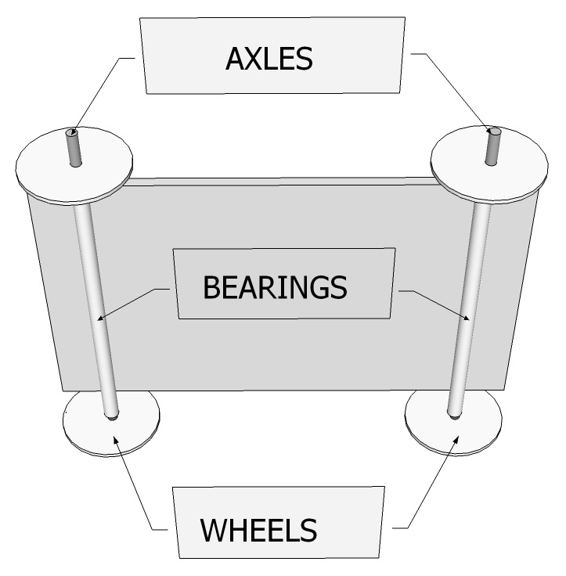

* **When force slows the buggy down?** Friction

**Slide 3 – Identify the wheels, axles and bearings on this diagram:**

**How do they work?**

The bearings hold the axles in position, whilst allowing them to rotate. The wheels fit tightly on the axles and rotate with them.

**Slide 4 – Sources of friction**

* **Suggest some pairs of surfaces which could rub and slow the buggy down.**
* Axles and bearings
* Wheels and bearings
* Wheels and buggy base (if bearings are too short)
* Wheels and floor
* Balloon and floor (e.g. as balloon goes down)
* **Suggest some ways in which this rubbing could be reduced or prevented.**
* Axles and bearings:
  + When cutting the straw to length it needs to be cut cleanly across to make a smooth end. Also, it can become flattened so it needs to be rounded out by pushing a pencil into the end and rotating it. This helps to allow the axles to turn freely in the bearings.
  + Make sure you don’t bend or crush your straw when attaching it.
  + Don’t get glue on the axles.
* Wheels and bearings:
  + Make sure the wheels are not pushed hard up against the ends of the straws – leave a small gap.
* Wheels and buggy base:
  + Make sure the straws are long enough to overlap the sides of the buggy base, to stop the wheels rubbing against the base.
* Wheels and floor:
  + Make a lightweight buggy.
  + If the axles are rotating freely then the wheels should roll along the floor, giving very low friction. However, if they are not rotating freely then the wheels slide along the floor, giving high friction.
* Balloon and floor:
  + You could move the hose back or shorten it so that the balloon rests on the buggy base as it goes down instead of dragging on the floor.
  + You could extend the front of your buggy so the balloon rests on it.
  + You could use bigger wheels at the front of the buggy, or prop up the hose to, help lift the balloon away from the floor.

**Slides 5 & 6**

Show the pupils the materials and tools which they will have so that they know what they will be able to use for their buggy design.

**Slide 7**

Fast cars don’t appeal to everyone! As well as encouraging the pupils to optimise the performance of their buggies, there is a lot of merit in encouraging them to experiment and try out unusual designs, and also to making their designs attractive and appealing.

**Slide 8**

Keep an eye on the designs to make sure they look feasible and are likely to work! For example, make sure they have left enough space to blow down one end of the hose and fit the balloon to the other end. Very heavy designs or ones with multiple axles are not likely to go as far, but they could be contenders for the most creative or nicest looking design. Multiple balloon designs have proved difficult to operate!

**Slide 10**

The ends of the straws need to be cut off cleanly so they don’t rub on the axles. Also, the ends can become flattened so they need to be rounded out by pushing a pencil into the end and rotating it. It is recommended to have a competent adult supervising the gluing process. The reason for holding the ends of the straws during gluing is to stop the pupils burning their fingers on the hot glue. Make sure the straws overlap the edges of the bases; otherwise the wheels can rub against the edges of the base during operation.

**Slide 12**

The wheels should fit tightly on the ends of the dowel. You should just need to round off the ends of the dowel a little with the sandpaper so that the wheels slide on easily. If the wheels are too loose, you can glue them on. If they are too tight you could open the holes up very slightly by pushing the end of the pencil into the hole and rotating it.

**Slide 13**

If the dowel diameter is on the large side the wheels may need their holes enlarging slightly with a pencil to get them on (but not too much, as they need to fit tightly). Check the axles turn easily in the bearings. Look out for problems such as bent straws or glued up axles, which will need to come off and be replaced.

**Slide 16**

Here are some suggestions for why the higher performance buggies may have travelled further:

* The balloon is blown up more
* The friction between the moving parts is less
* The axles spin more easily in the bearings
* The buggies are lighter
* They have a larger or higher quality balloon
* The balloon doesn’t drag on the floor as it goes down

Copyright © Caroline Alliston 2020