Sparkle Rug User Guide

**Important Information**

* Please read these instructions carefully before using the Sparkle Rug.
* Please retain this information for future reference as it contains important information

**Battery Information**

* The sparkle rugs are supplied with non-replaceable Lithium Ion batteries, do not attempt to replace the batteries.
* The batteries should be recharged by connecting the supplied micro-USB cables to an available USB port or USB charger. The battery packs are located in pouch(s) around the edge. Depending on the size of the rug there can be up to 4 separate battery packs.
* The rug will flash to indicate charging is taking place, and the lights will go out when charging is complete.
* The rug will take approximately 4 hours to fully charge when flat.
* Do not leave the rug on charge for long periods, it is good practice to only charge when it is fully discharged to preserve the useful life of the battery.

**Instructions for use**

* Press the button located on each charger cable to activate each area of the rug. It will change through a sequence of colour modes with multiple button presses and stay lit for 60 seconds.
* Tread firmly on the rug to light each area – it will stay lit for 60 seconds.
* If the rug no longer illuminates, connect the charger as described in the battery information section.
* To clean wipe with a soft damp cloth.
* Keep away from moisture and dirt.

  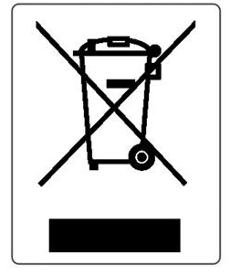

TTS Group Ltd.

Park Lane Business Park

Kirkby-in-Ashfield

NOTTINGHAM

NG17 9LE

Product Codes: SD10518, SD10372, SD10395